1. Name of the experiment:
Configuring static routing using CLI command.
2. Introduction:
In this experiment we will attempt to configure two different networks with each hosting two PCs to be interconnected and be able to share message from one network to other. Upon successful completion of this experiment, we should be able to successfully transfer message from one PC from one network to other PCs of another network.
3. Objectives:
- To create two different networks using two routers and two switches.
- Configure routers using CLI commands.
- Successfully share message across PCs in separate networks.
4. Tool:
Cisco packet tracer 9.0.0
5. Procedure:
Step 1: Place 4 PCs, 2 switches and 2 routers on the workspace in such a manner that every switch is positioned with a different router and two PCs that are not positioned with any other switch.
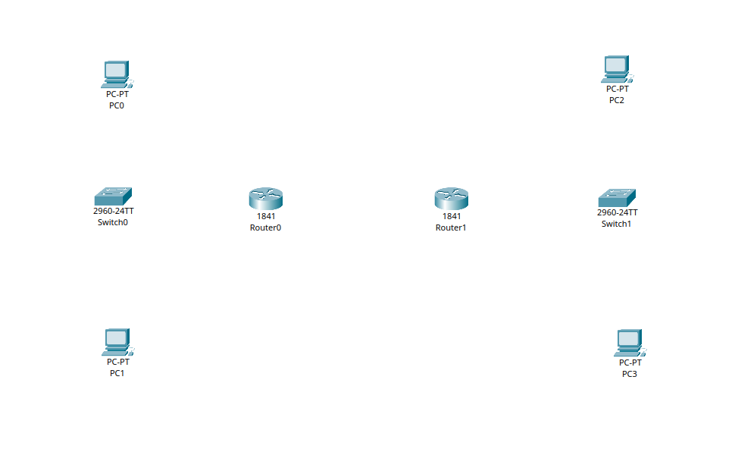
Figure 7.1: Place all components in workspace.
Step 2: Connect the PCs with corresponding switches, and switches with corresponding routers. In both cases copper straight through will be used.
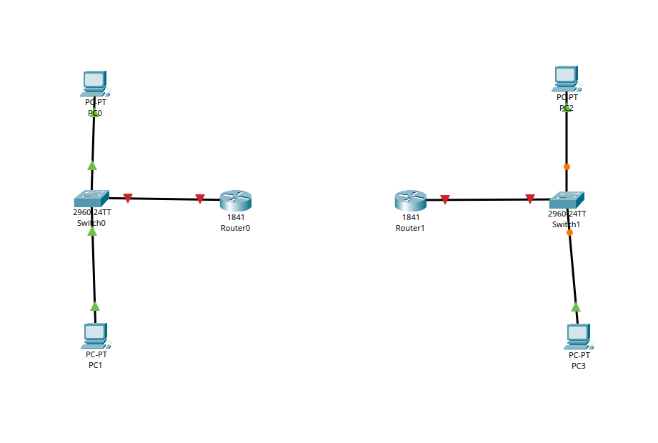
Figure 7.2: Connect PCs with switches and switches with routers.
Step 3: For Router0, from physical menu, turn off the router, add WIC-2T and restart the router. Do the same for Router1.
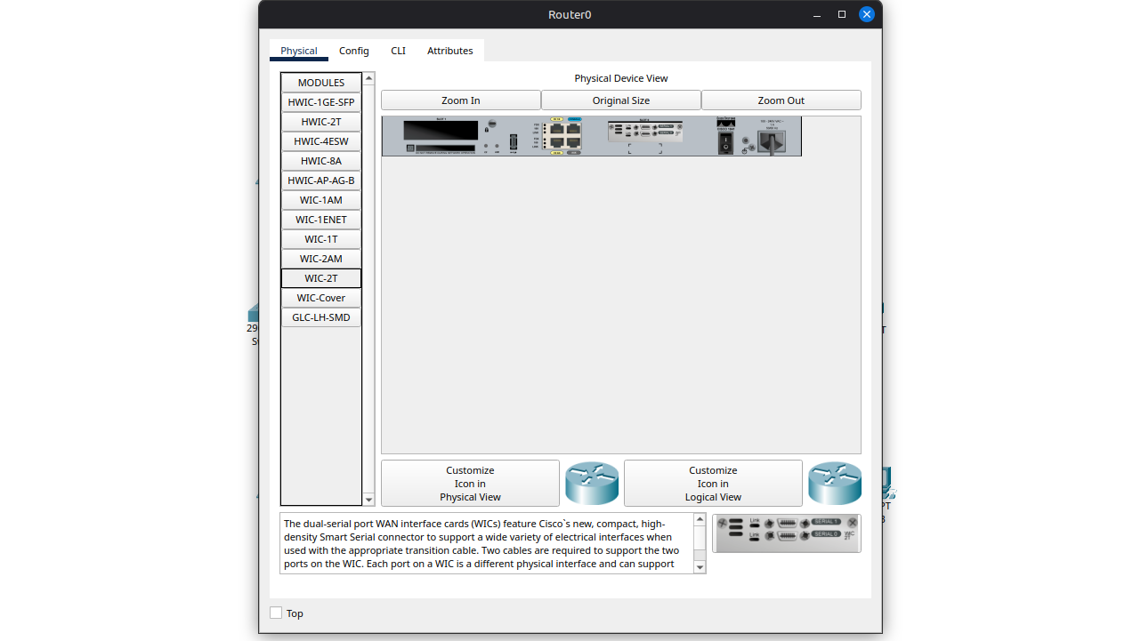
Figure 7.3: Add WIC-2T to Router0 and Router1.

Step 4: Connect a serial dte to Router0’s Serial0/0/0 and Router1’s Serial0/0/0.
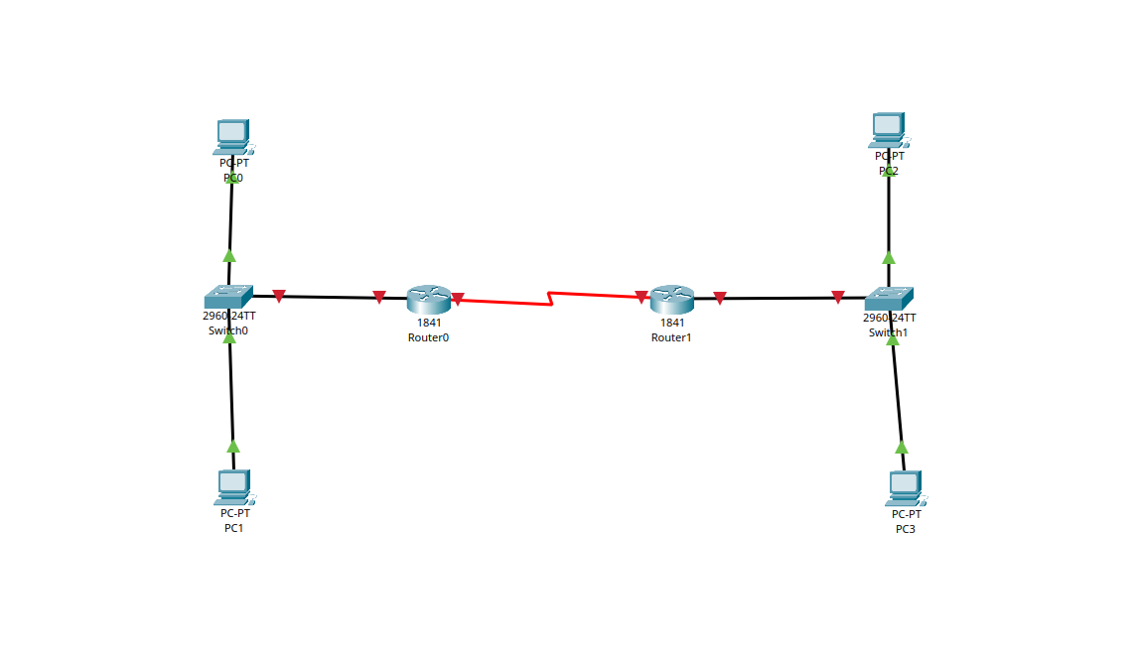
Figure 7.4: Connect routers via serial dte.
Step 5: Configure all the PCs with appropriate IP address and default gateway. For the first network, default gateway will be 192.168.10.1. For the second network, default gateway will be 192.168.11.1.
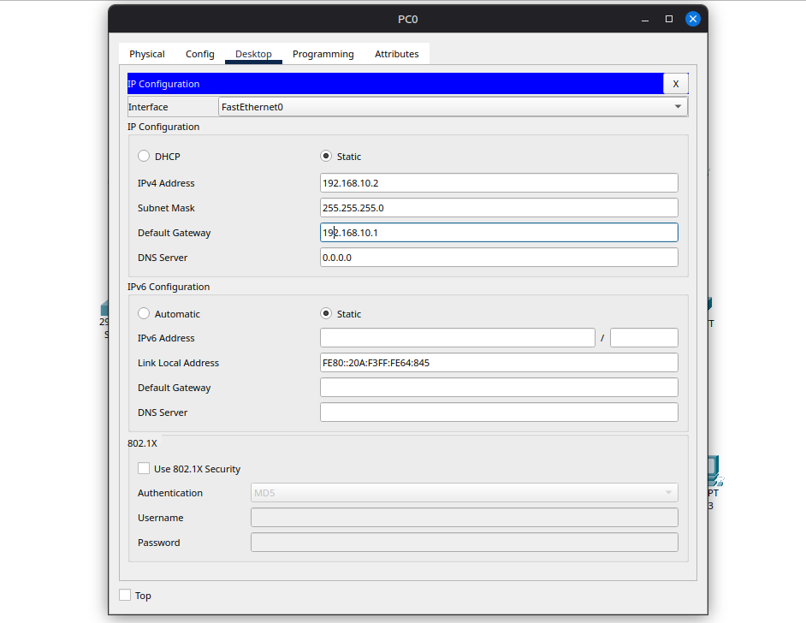
Figure 7.5: Configure PC0.
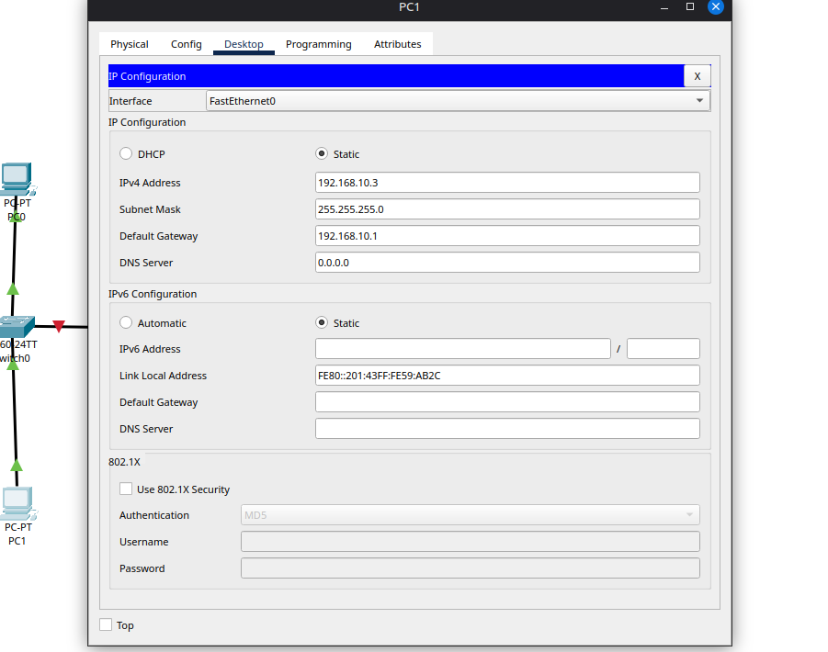
Figure 7.6: Configure PC1.
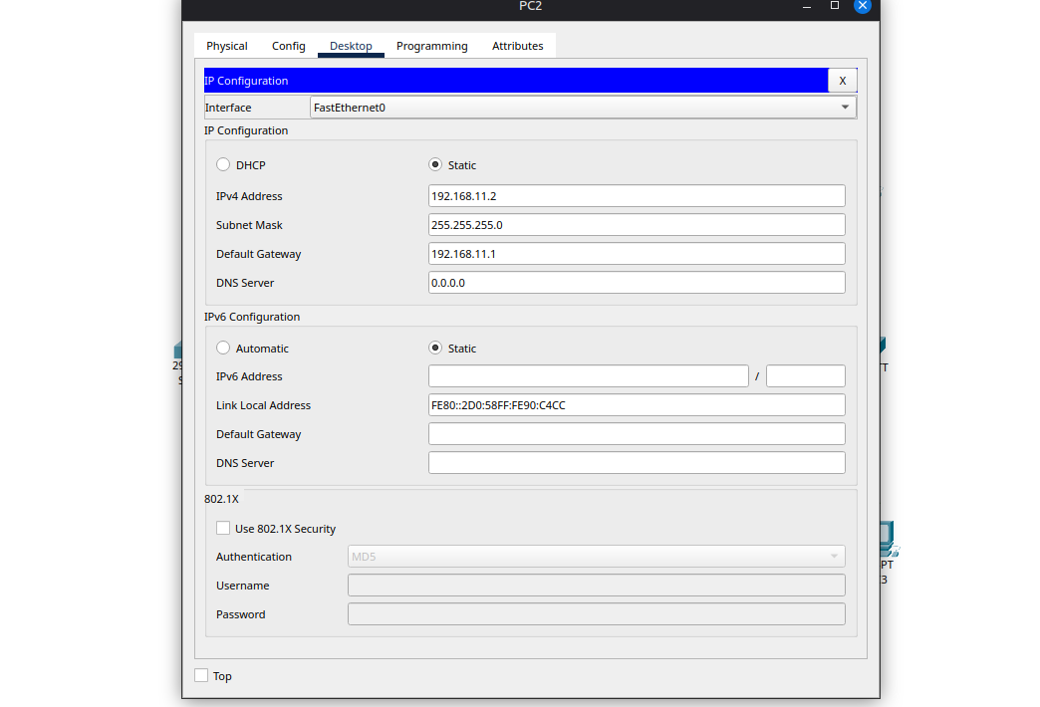
Figure 7.7: Configure PC2.
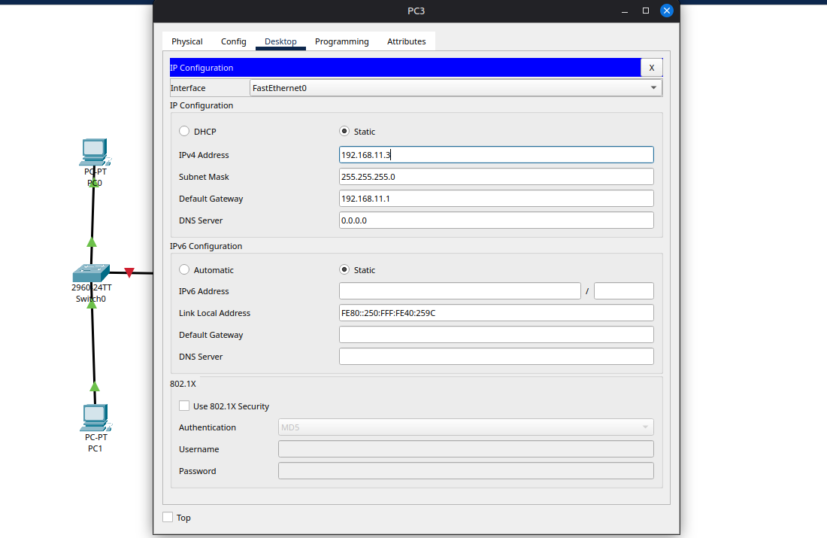
Figure 7.8: Configure PC3.
Step 6: Enter Router0’s CLI option and enable the router using CLI commands. Then configure FastEthernet0/0 and Serial0/0/0 using CLI commands. Then configure IP route in the same way. We need to remember this configuration so that we can configure Router1 according to this.
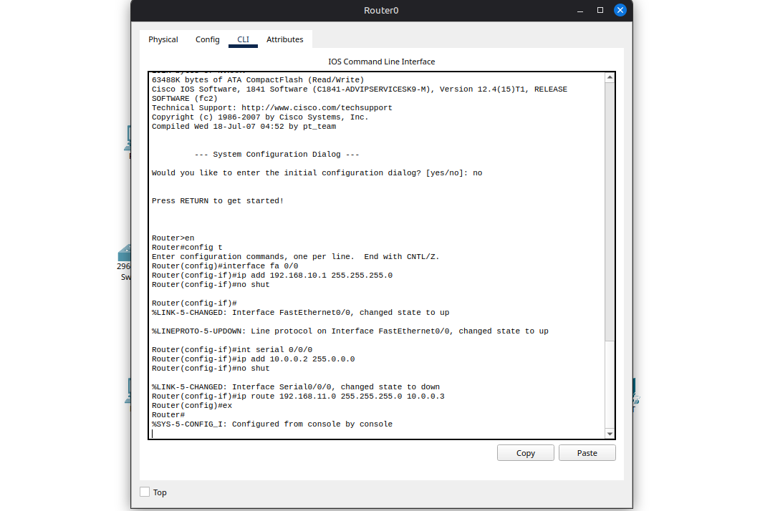
Figure 7.9: Configure Router0 using CLI commands.
Step 7: Enter Router1’s CLI option and enable the router using CLI commands. Then configure FastEthernet0/0 and Serial0/0/0 using CLI commands. Then configure IP route according to the configuration of Router0.
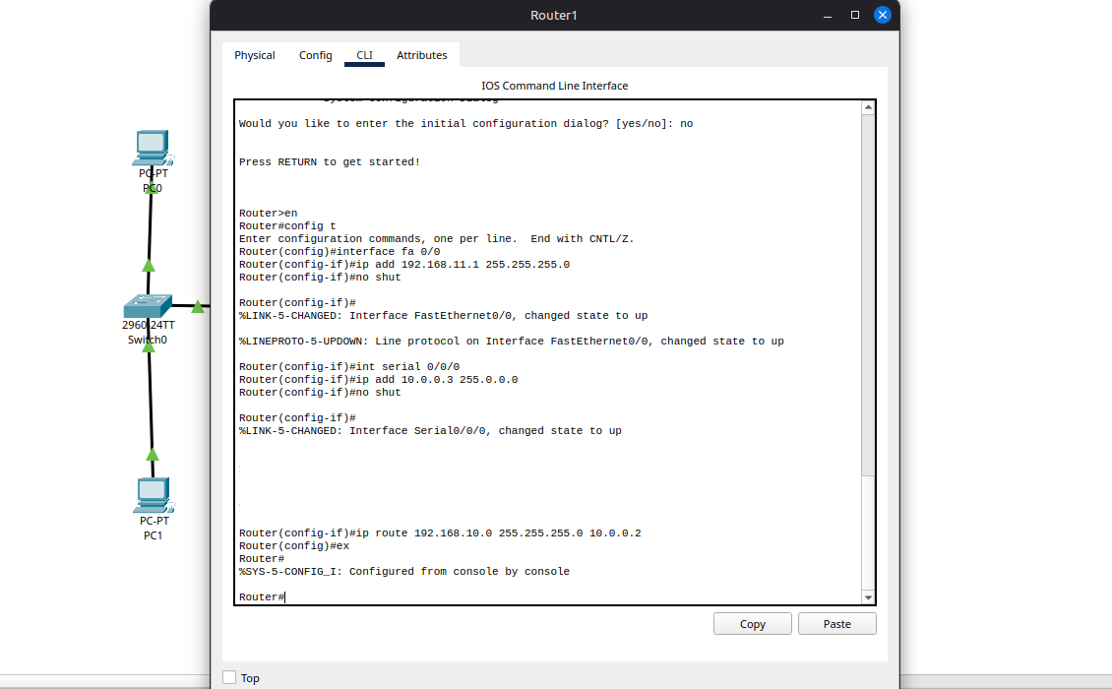
Figure 7.10: Configure Router1 using CLI commands.
Step 8: After I attempted transferring message from PC of one network to PC of other network, all the attempts of every combination returned successful message.
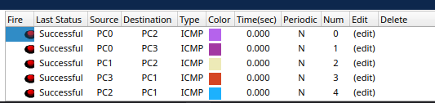
Figure 7.11: Message transfer successful.
6. Result: We were able to transfer message from any one PC to any other PC of same and different network. Every combination of PCs in message transfer turned out to be successful.
7. Conclusion: In this experiment we successfully connected two networks together and message transfer from one network to other was also successful. We observed how we can easily use WIC-2T, serial ports and proper configuration using CLI to connect networks.

